Support Vector Clasification

Ian R. Stewart

December $8^{th}$, 2018

Fall 2018 – COSC 528
Project 5

Abstract

Table of Contents

1 Introduction 5
1.1. Ionosphere Dataset 5
1.2. Vowel Sounds Dataset 5
1.3 Satellite Imagery Dataset 5
1.4 Overview of SVM 5
2 Data Exploration 7
2.1 Ionosphere Dataset 7
2.2. Vowel Sound Dataset 7
2.3 Satellite Imagery Dataset 9
3 Data Analysis 9
3.1. Ionosphere Dataset 9
3.2 Vowel Sound Dataset 11
3.3 Satellite Imagery Dataset 13
References 14

List of Tables
Table 1: Number of unique values in vowel sound data. 8

List of Figures
Figure 1: Equation for the Radial Basis Function kernel. 6
Figure 2: Equation for Linear kernel. 6
Figure 3: Equation for Polynomial kernel. 6
Figure 4: Equation for Sigmoid kernel. 6
Figure 5: Number of unique values in ionosphere data. 7
Figure 6: Number of unique values in vowel sound data. 8
Figure 7: Screenshot of data split and SVC accuracy for ionosphere dataset. 9
Figure 8: Confusion matrix and classification report using default SVC for ionosphere dataset. 10
Figure 9: Screenshot of coarse grid search for ionosphere dataset. 10
Figure 10: Screenshot of fine grid search for ionosphere data. 11
Figure 11: Screenshot of data split and SVC accuracy for vowel sound dataset. 11
Figure 12: Classification report using default SVC for vowel sound dataset. 12
Figure 13: Screenshot of coarse grid search for vowel sound dataset. 12

1 Introduction
This project applies support vector classifications (SVC) to three unique datasets using a prebuilt Python SVC library. The three classification problems are as follows:
- binary classification on ionosphere dataset using radar signals,
- eleven-class classification on audible vowel sounds, and
- seven-class classification on multispectral value from satellite images.
A brief overview of the data for the three problems is provided in the following subsections.

Ionosphere Dataset
The ionosphere dataset was collected in Goose Bay, Labrador, Canada in 1989 via an array of 16 high-frequency antennas. The antennas measure the free electrons in the Earth’s ionosphere and classifies the data array as either ‘g’ for good of ‘b’ for bad, which correspond to the whether the data shows evidence for some type of structure (good) or no structure (bad). The dataset contains 34 features and 351 instances containing integer, real values. The last column (35th feature) contains the binary classification data as a string.

Vowel Sounds Dataset
The vowel sounds dataset was collected in the Cambridge, England and contains data for eleven steady state vowels sounds (classes) and 10 data features. Fifteen participants were used to create the dataset with each participant saying each vowel 6 times. Three features are provided along with the vowel sound data: Train or Test, Speaker Number, and Sex. This results in 14 total data features, including the classification, and 990 instances.

1.3 Satellite Imagery Dataset
The satellite imagery dataset was collected in Glasgow, Scotland consisting of multi-spectral values of pixels in (3 x 3) neighborhoods in a 82 x 100 sub-area of a satellite image. The classification associated with the data corresponds to the central pixel in each neighborhood. The classes in the dataset correspond to the one of eight classification of the images: (1) red soil, (2) cotton crop, (3) grey soil, (4) damp grey soil, (5) soil with vegetation stubble, (6) mixture class (none present), and (7) very damp grey soil. In total, 36 features comprise the dataset with 4435 and 2000 instances in the presplit training and test datasets, respectively.

1.4 Overview of Analysis Techniques
Support vector machines (SVM) are a powerful and widely implemented learning algorithm, which can be thought of as an extension of the perceptron. Using a perceptron for regression or classification purposes, the error (e.g. misclassification error, Gini coefficient, or entropy) is minimized, where a SVM is optimized by maximizing the margin. The margin in this case is defined as the distance between the decision boundary and the training values closest to the boundary (i.e. these values are referred to as the support vectors). The SVM has the ability to be kernelized to solve nonlinear problems, which increases the algorithm’s popularity among practitioners. The basic idea behind the kernel methods implemented in SVMs is to create nonlinear combinations of the original data features in order to obtain a decision boundary for linearly inseparable data (i.e. project the data into a higher dimensional space where the data is linearly separable).
A potential drawback to the projecting or mapping the data into a higher dimensional space with new features can increase the computation time required to solve the regression or classification. To solve this issue, a task referred to as the kernel-trick is performed. The kernel trick removes an expensive dot product computation of the original data with a inner product of the mapping function. To accomplish this, several kernel functions (i.e. can be thought of as a similarity function between a pair of samples) have been created with the most widely used kernel being the Radial Basis Function. This kernel is rarely referred to as a Gaussian kernel and minus sign inside the exponential inverts the distance measure into a score value ranging between 1 (similar) and 0 (dissimilar).
$$k\left(x^{i},y^{j}\right)=\exp\left(-\frac{\left\|x^{i}-{\left.x^{j}\right\|}^{2}\right.}{2σ^{2}}\right)=\exp\left(-γ\left\|x^{i}-{\left.x^{j}\right\|}^{2}\right.\right)$$

Figure 1: Equation for the Radial Basis Function kernel.
Where, $γ$ is a free parameter to be optimized equal to ${\left(2σ^{2}\right)}^{-1}$.

Other common kernels are the Linear kernel, Polynomial kernel, and the Sigmoid kernel. The kernels function for these kernels are as follows.

$$k\left(x,y\right)=x^{T}y+c$$
Figure 2: Equation for Linear kernel.
Where, $c$ is a free parameter to be optimized.

$$k\left(x,y\right)={(αx}^{T}y+{c)}^{d}$$
Figure 3: Equation for Polynomial kernel.
Where, $α, c, and d$ are a free parameter to be optimized.

$$k\left(x,y\right)=\tanh\left(αx^{T}y+c\right)$$
Figure 4: Equation for Sigmoid kernel.
Where, $α and c$ are a free parameter to be optimized.

In order to obtain optimal parameters for each kernel, a grid search is used exhaustively search over specified parameter values. The parameters of the estimator are further optimized by cross-validating the grid search over a parameter grid. For example, if the Radial Basis Function is picked as the kernel function for the SVC, the cross validation can optimize the error term and the $γ$ parameters. Within Python, this is accomplished via the sklearn.model_selection library’s GridSearchCV( ) function. This is the function that will be implemented in this project to first find optimal values via a coarse search and subsequently a fine search.

2 Data Exploration
The datasets for each of the three problems in this project are explored independently in the following subsections.

2.1 Ionosphere Dataset
The ionosphere dataset contained 35 total features, where the final feature contains the classification data for the data instances. The classification data only contained two classes (binary classification) corresponding to good or bad signal. The dataset features, minus the classification column, contained two columns with integer values. The first and second columns of the dataset contain two and one unique value, respectively. The first feature contains values of either 0 or 1 and the second feature contains all zeros. The number of unique values per data feature is provided in Figure 5.
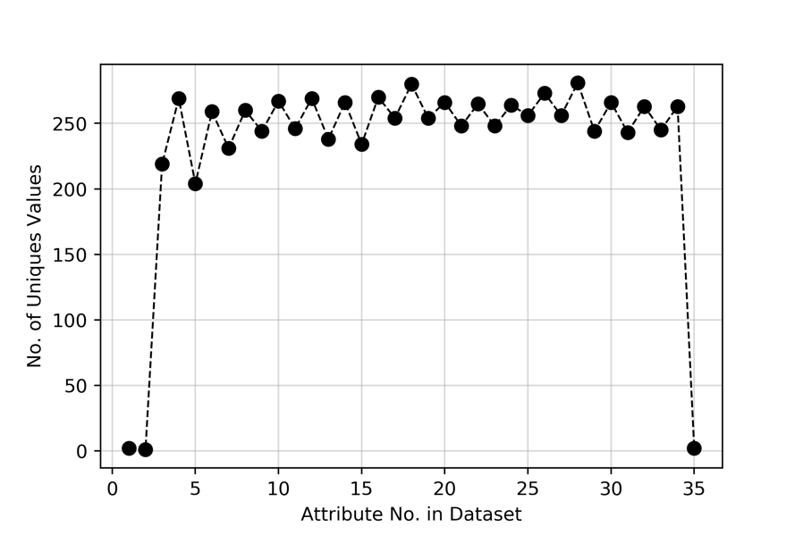
Figure 5: Number of unique values in ionosphere data.
The data was checked for missing or NaN (not a number) values resulting in all values accounted for in the dataset. The data was then standardized between $-1$ and $1$ in order to assist the SVC process.

2.2. Vowel Sound Dataset
The vowel dataset contained a total of 14 features, including the classification column, and 990 instances. The number of unique values in each data feature was analyzed to check for any trends in the data with results provided in Figure 6 and Table 1.
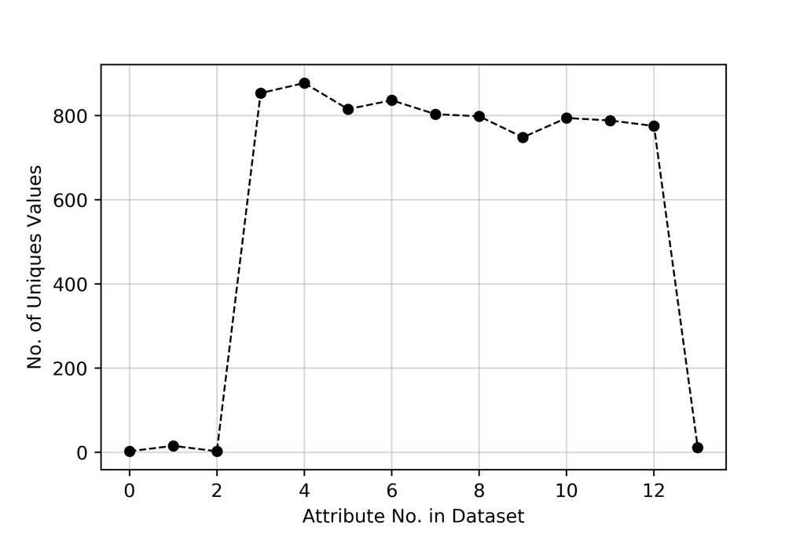
Figure 6: Number of unique values in vowel sound data.

Table 1: Number of unique values in vowel sound data.
Feature | No. of Unique
Train or Test | 2
Speaker Number | 15
Sex | 2
Feature 0 | 853
Feature 1 | 877
Feature 2 | 815
Feature 3 | 836
Feature 4 | 803
Feature 5 | 798
Feature 6 | 748
Feature 7 | 794
Feature 8 | 788
Feature 9 | 775
Class | 11

The first three data features (Train or Test, Speaker Number, Sex) were not used in the data analysis portion, as each deemed irrelevant, leaving 10 data features used for the data analysis. The remaining data features were standardized, resulting in all float data types for the data features, except for the classification column. The data was checked for missing or NaN (not a number) values resulting in all values accounted for in the dataset. The data was then standardized between $-1$ and $1$ in order to assist the SVC process.

2.3 Satellite Imagery Dataset
Two datasets were provided for the satellite imagery dataset: one specifically for training with 4435 instances and the other for a test set containing 2000 instances. Both datasets provided contained 36 features, all of which containing integer values with no missing or NaN values. Seven classes are employed in the dataset with no values for one of the classes, resulting only six classes actually represented in the dataset. The number of unique values for each data feature was analyzed with the results provided in .

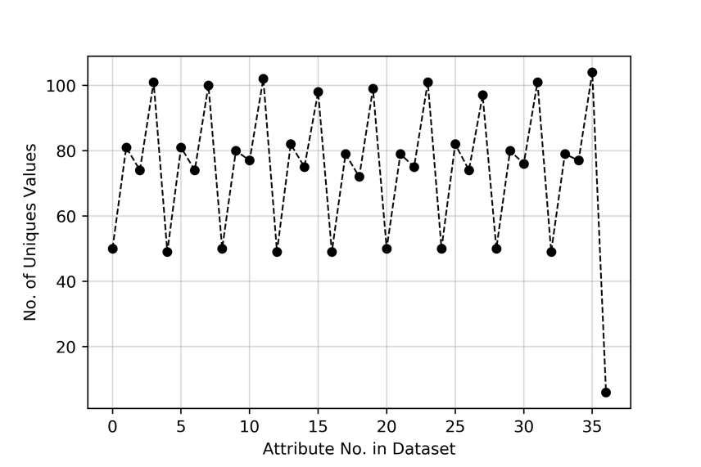
Figure 7: Number of unique values in satellite data.
Table 2: Number of unique values in vowel sound data.
Feature | No. of Unique |  | Feature | No. of Unique
Feature 1 | 50 |  | Feature 19 | 72
Feature 2 | 81 |  | Feature 20 | 99
Feature 3 | 74 |  | Feature 21 | 50
Feature 4 | 101 |  | Feature 22 | 79
Feature 5 | 49 |  | Feature 23 | 75
Feature 6 | 81 |  | Feature 24 | 101
Feature 7 | 74 |  | Feature 25 | 50
Feature 8 | 100 |  | Feature 26 | 82
Feature 9 | 50 |  | Feature 27 | 74
Feature 10 | 80 |  | Feature 28 | 97
Feature 11 | 77 |  | Feature 29 | 50
Feature 12 | 102 |  | Feature 30 | 80
Feature 13 | 49 |  | Feature 31 | 76
Feature 14 | 82 |  | Feature 32 | 101
Feature 15 | 75 |  | Feature 33 | 49
Feature 16 | 98 |  | Feature 34 | 79
Feature 17 | 49 |  | Feature 35 | 77
Feature 18 | 79 |  | Feature 36 | 104
 |  |  | Class | 6
No data features can be dropped from the unique value analysis, as all are relevant and no single valued features. The data was checked for missing or NaN (not a number) values resulting in all values accounted for in the dataset. The data was then standardized between $-1$ and $1$ in order to assist the SVC process.

3 Data Analysis
Similar to that of the previous section, each problem is analyzed independently in the following subsections providing the optimal parameters to provide the highest level of accuracy on the test (validation) dataset. The confusion matrix and other performance metrics are provided where applicable.

3.1. Ionosphere Dataset
The ionosphere dataset was randomly 40%-60% split into a training set and test set using a created test_split( ) function. Implementing the SVC( ) function with default inputs in Python’s sklearn.svm library, the accuracy on the training set and test set resulted in 95.0% and 88.15%, respectively. The SVC( ) function defaults to a Radial Basis Function kernel, a penalty parameter $\left(C\right)$ of 1.0, and gamma parameter calculated as the inverse of (no. of features × data standard deviation).

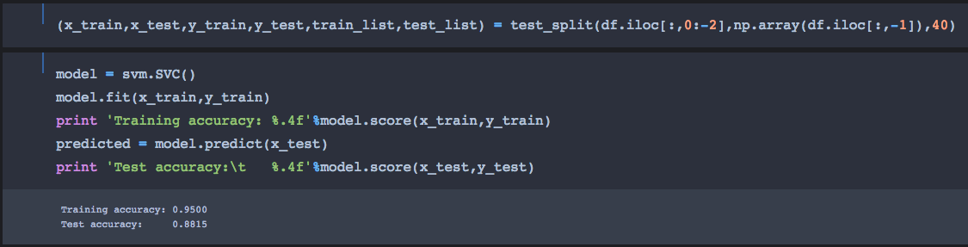
Figure 8: Screenshot of data split and SVC accuracy for ionosphere dataset.
As this is a binary classification, a previously created function to create a confusion matrix was implemented on the predicted values along with sklearn.metrics library classification_report( ) function output. Using this training-test split, 25 misclassifications were calculated of the test set, resulting in the 88.15% accuracy (i.e. 25/211*100 results in 11.85% misclassification error). Important to note, since the dataset is randomly split into a training and test set, the accuracy will change depending on which instances are used for the two datasets.

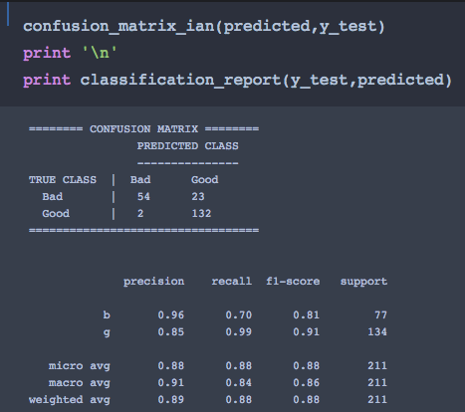
Figure 9: Confusion matrix and classification report using default SVC for ionosphere dataset.
A grid search was subsequently performed to obtain assist in parameter optimization of the SVC. Initially, coarse grid was implemented using a penalty values $\left(0.1, 1, 5, 10\right),$ gamma values of $\left(0.001, 0.01, 0.1, 1\right)$, kernel functions $\left(linear, radial basis function,sigmoid, polynomial\right)$ five cross validations. This resulted in a penalty value of 1.0, gamma value of 0.1 and Radial Basis Function kernel.

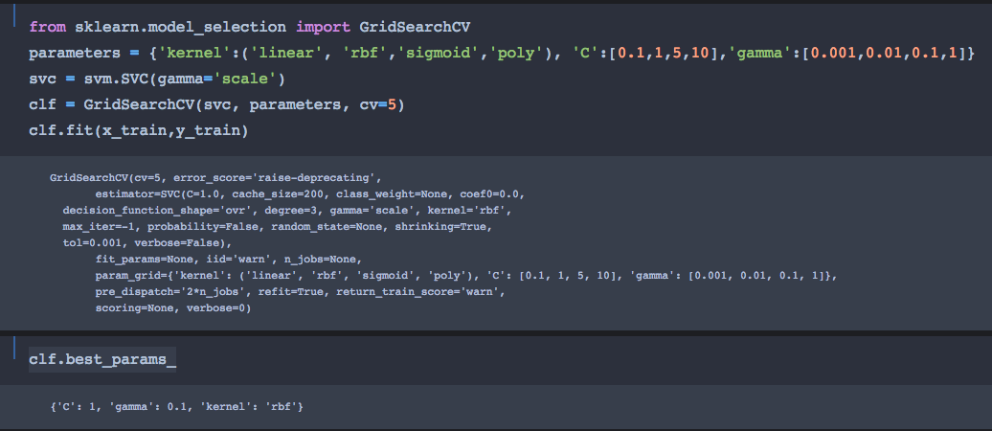
Figure 10: Screenshot of coarse grid search for ionosphere dataset.
A penalty value of 1.0 was chosen for the optimal kernel function Radial Basis Function using a gamma value of 0.1. A fine grid search was then performed using the following ranges of values for the Radial Basis Function: C-value [0.5 to 3 in 25 steps] and Gamma-value [0.01 to 0.8 in 20 steps].

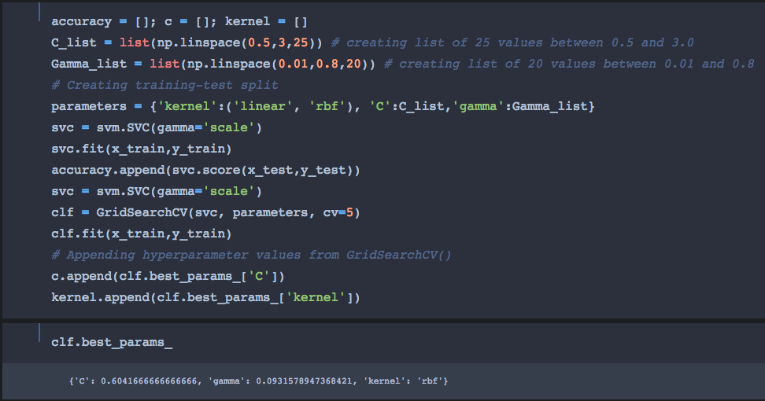
Figure 11: Screenshot of fine grid search for ionosphere data.
For this training-test split, the fine grid search resulted in the following values for the hyperparameters for five cross validations: C-value of 0.604 and Gamma-value of 0.093 for the Radial Basis Function. Using these values, SVC( ) was performed on the test set and resulted in 91.47% accuracy; a 3.32% accuracy increase from the default run.

3.2 Vowel Sound Dataset
Similar to the ionosphere dataset, the vowel sound dataset was randomly 40%-60% split into a training set and test set using a created test_split( ) function. Implementing the SVC( ) function with default inputs in Python’s sklearn.svm library, the accuracy on the training set and test set resulted in 95.2% and 84.51%, respectively. The SVC( ) function defaults to a Radial Basis Function kernel, a penalty parameter $\left(C\right)$ of 1.0, and gamma parameter calculated as the inverse of (no. of features × data standard deviation).

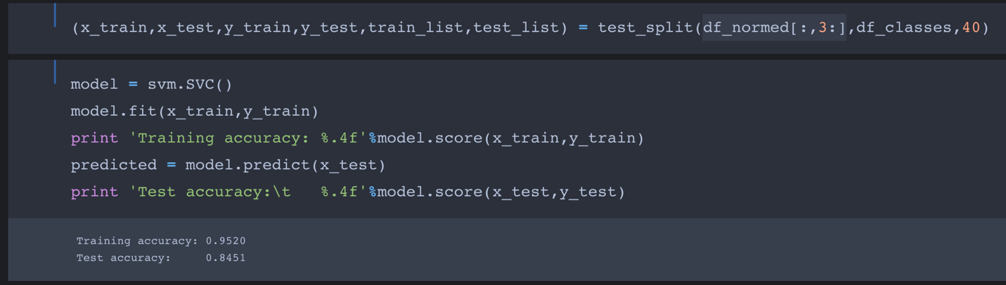
Figure 12: Screenshot of data split and SVC accuracy for vowel sound dataset.
Using the sklearn.metrics library classification_report( ) function, the following Figure 12 shows the function output for the fit performance metrics.

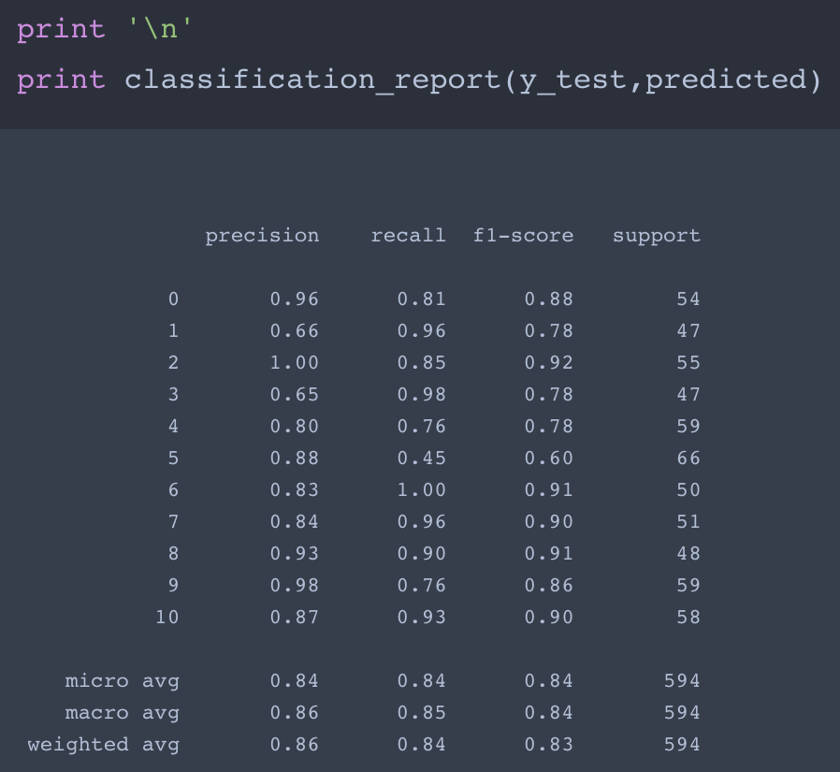
Figure 13: Classification report using default SVC for vowel sound dataset.
Even though accuracy values of 95.2% and 84.51% for the training and test sets are relatively high, the accuracy can potentially be improved by optimizing the hyperparameters via a grid search using cross validation. Identical parameters as the ionosphere were used for the hyperparameters: penalty values $\left(0.1, 1, 5, 10\right),$ gamma values of $\left(0.001, 0.01, 0.1, 1\right)$, kernel functions $\left(linear, radial basis function,sigmoid, polynomial\right)$ and five cross validations. This resulted in a penalty value of 10, gamma value of 0.1 and Radial Basis Function kernel.

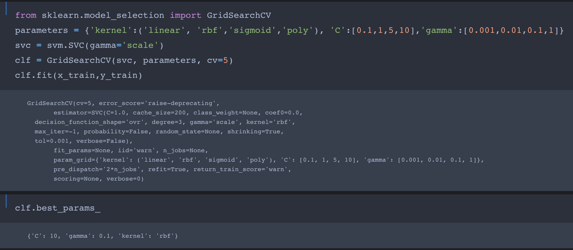
Figure 14: Screenshot of coarse grid search for vowel sound dataset.
A fine grid search was then performed using the following ranges of values for the Radial Basis Function: C value [7.5 to 15 in 50 steps] and Gamma value [0.01 to 0.1 in 20 steps]. The results from the fine grid are provided in .

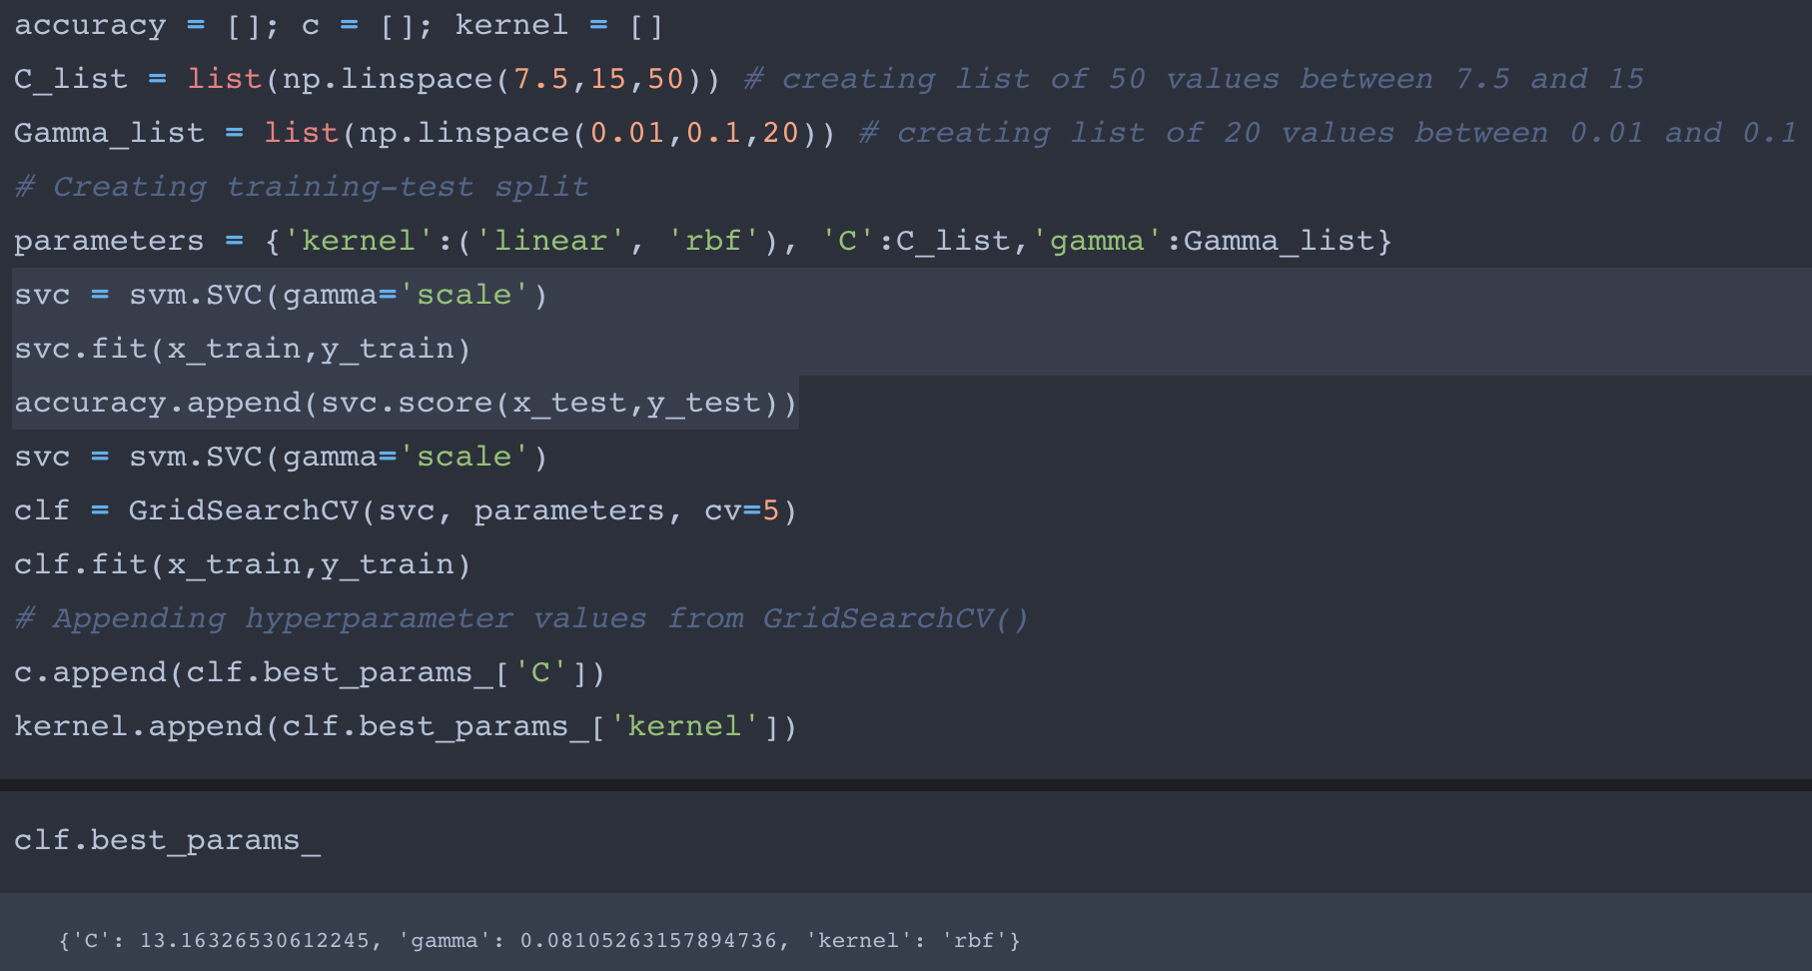
Figure 15: Screenshot of fine grid search for vowel sound data.
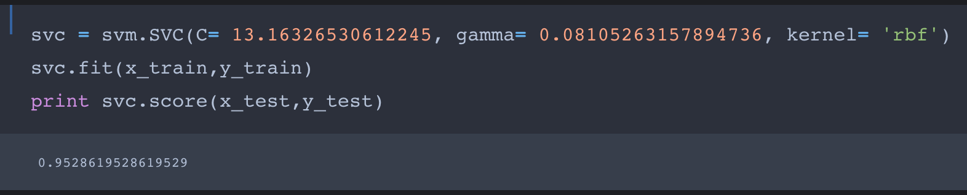
Figure 16: Accuracy of SVC using optimal values for vowel sound data.

The fine grid search resulted in the following values for the hyperparameters for five cross validations: C-value of 13.16 and Gamma-value of 0.081 for the Radial Basis Function. Using these values, SVC( ) was performed on the test set and resulted in 95.28% accuracy; a 10.78% accuracy increase from the default run.

3.3 Satellite Imagery Dataset
The satellite imagery dataset was not randomly split, as two unique datasets were already provided to train and test the algorithm. Implementing the SVC( ) function with default inputs in Python’s sklearn.svm library, the accuracy on the training set and test set resulted in 90.96% and 89.95%, respectively. The SVC( ) function defaults to a Radial Basis Function kernel, a penalty parameter $\left(C\right)$ of 1.0, and gamma parameter calculated as the inverse of (no. of features × data standard deviation).

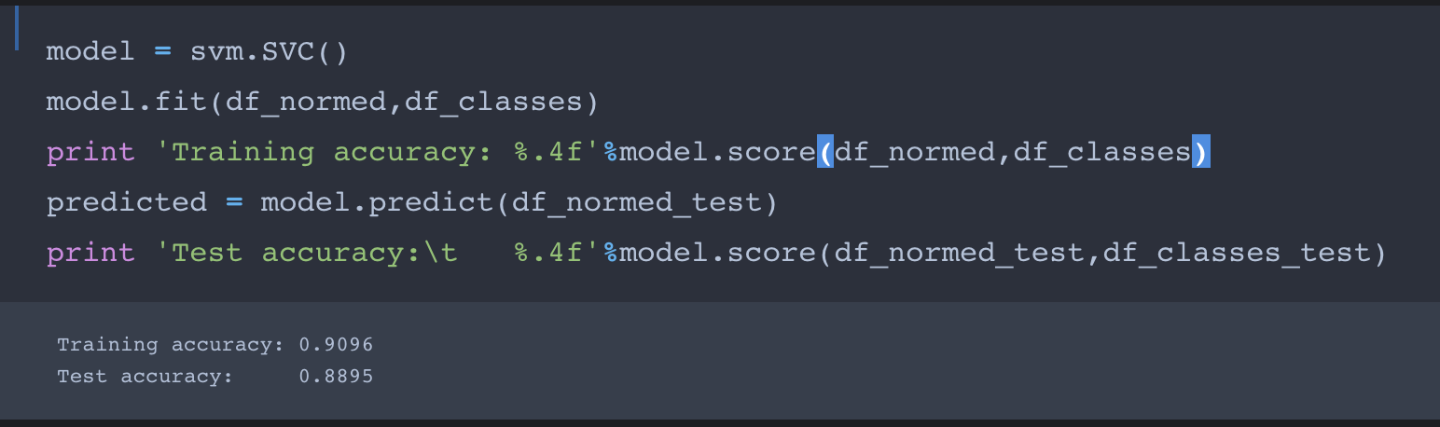
Figure 17:
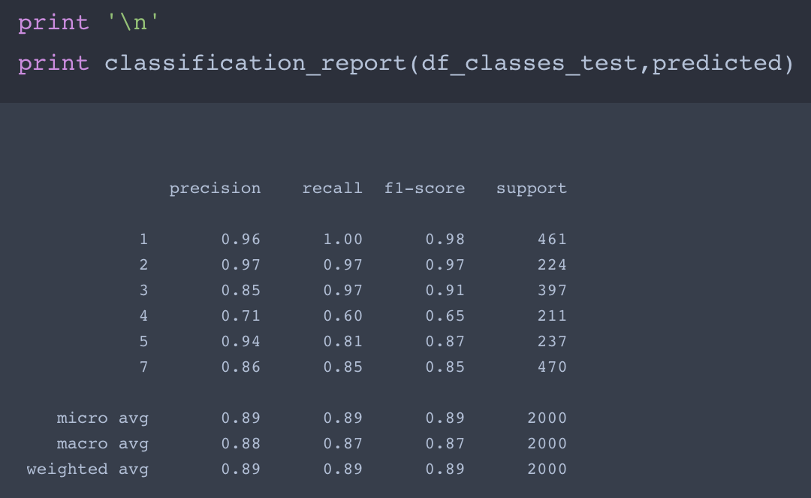
Figure 18:

A coarse grid search was then performed penalty values $\left(0.1, 1, 5, 10\right),$ gamma values of $\left(0.001, 0.01, 0.1, 1\right)$, kernel functions $\left(linear, radial basis function,sigmoid, polynomial\right)$ and five cross validations. This resulted in a penalty value of 10, gamma value of 0.1 and Radial Basis Function kernel.

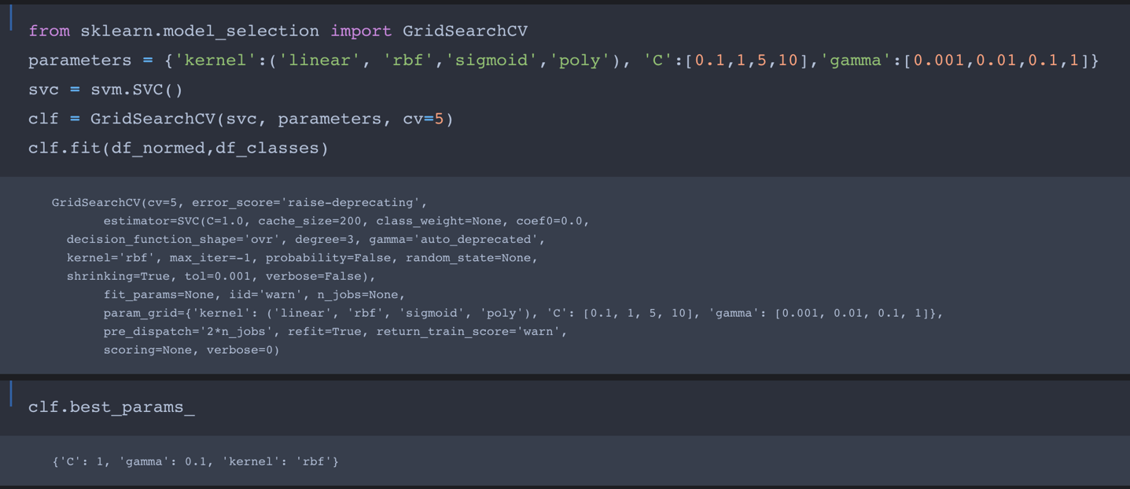
Figure 19:

Using these values from the coarse grid search, a range of values for hyperparameters are used to optimize the learning algorithm. The range of values utilized for the fine coarse search are as follows: C-values from 0.5 to 3 in 25 steps and Gamma-values from 0.01 to 0.8 in 20 steps.

References
Alpaydin, Ethem. Introduction to Machine Learning. Third Edition. The MIT Press. Cambridge, Massachusetts. (2014). ISBN: 978-0-262-02818-9.

Raschka, Sebastian. Python Machine Learning. Packt Publishing Ltd. Birmingham, UK. (2015). ISBN: 978-1-78355-513-0.

The scikit-learn Python package contains support vector machine (SVM) library that is based on the popular, open source LIBSVM library. For further information regarding the class and the syntax, the reader can review the documentation found at: https://scikit-learn.org/stable/modules/generated/sklearn.svm.SVC.html.

